Ex.N.3: Spectrum Analysis of Sub-1 GHz, Mid-band & mmWave by Plotting Propagation Loss. Date

AIM:
To analyze the propagation loss characteristics of different frequency bands (Sub-1 GHz, Midband, and mmWave) in wireless communication systems and compare their performance over varying distances using MATLAB.
Objective :

- To compute the Propagation Loss (dB) for Sub-1 GHz, Mid-band, and mmWave frequency ranges using standard path loss models.
- To evaluate the impact of different Operating Frequencies (GHz) on signal attenuation and coverage performance.
- To analyze how Communication Distance (km) affects propagation loss across different spectrum bands.
Procedure
- Define frequency bands: Sub-1 GHz (0.9 GHz), Mid-band (3.5 GHz), and mmWave (28 GHz).
- Set communication distance range (e.g., 0.1 km to 5 km).
- Use Free Space Path Loss (FSPL) formula to compute propagation loss: PL(dB)=20log⁡10(d)+20log⁡10(f)+32.44
- Calculate propagation loss for each frequency band over varying distances.
- Plot distance vs propagation loss curves for comparison.
- Analyze how higher frequencies experience higher attenuation.
- Compare coverage efficiency of each spectrum band.
- Display results using MATLAB plots.

Objective 1: Matlab Code and Output:
clc;
clear;
close all;

d = 0.1:0.1:5; % Distance (km)
f = [900 3500 28000]; % Frequency (MHz)

% Propagation loss calculation
PL1 = 32.44 + 20*log10(f(1)) + 20*log10(d);
PL2 = 32.44 + 20*log10(f(2)) + 20*log10(d);
PL3 = 32.44 + 20*log10(f(3)) + 20*log10(d);

figure;

% -------- Graph 1: Propagation Loss vs Distance --------
subplot(2,1,1);

plot(d, PL1, 'b', 'LineWidth', 2);
hold on;
plot(d, PL2, 'r', 'LineWidth', 2);
plot(d, PL3, 'k', 'LineWidth', 2);

title('Propagation Loss vs Distance');
xlabel('Distance (km)');
ylabel('Loss (dB)');
legend('900 MHz', '3500 MHz', '28000 MHz');
grid on;

% -------- Graph 2: Propagation Loss vs Frequency --------
subplot(2,1,2);

Freq = [900 3500 28000];

% Loss at approximately 1 km
Loss = [PL1(10) PL2(10) PL3(10)];

plot(Freq, Loss, '-o', 'LineWidth', 2);

title('Propagation Loss vs Frequency');
xlabel('Frequency (MHz)');
ylabel('Loss (dB)');
grid on;
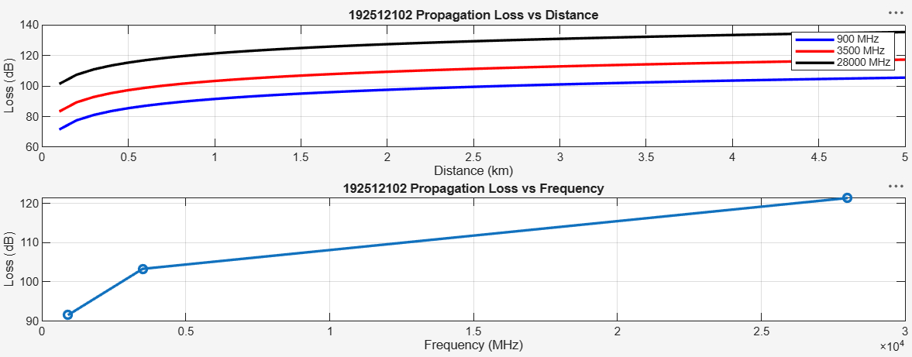
Objective 2: Matlab Code and Output:
clc;
clear;
close all;

d = 2; % Fixed distance (km)
f = [900 3500 28000]; % Frequency (MHz)

% Propagation loss calculation
PL = 32.44 + 20*log10(f) + 20*log10(d);

figure;

% -------- Graph 1: Frequency vs Loss --------
subplot(2,1,1);

plot(f, PL, '-o', 'LineWidth', 2);
title('Propagation Loss vs Operating Frequency');
xlabel('Frequency (MHz)');
ylabel('Propagation Loss (dB)');
grid on;

% -------- Graph 2: Band Comparison --------
subplot(2,1,2);

bar(PL);
title('Comparison of Propagation Loss Across Bands');
xlabel('Frequency Bands');
ylabel('Propagation Loss (dB)');

xticklabels({'Sub-1GHz', 'Mid-band', 'mmWave'});
grid on;
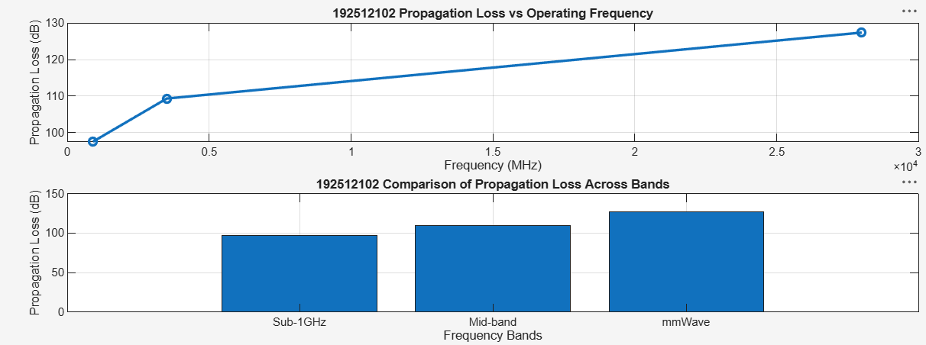
Objective 3: Matlab Code and Output:
clc;
clear;
close all;

% Frequency bands (MHz)
f = [900 3500 28000];

% Distance (km)
d = 2;

% Propagation Loss (FSPL)
PL = 32.44 + 20*log10(f) + 20*log10(d);

figure;

% -------- Graph 1: Frequency vs Propagation Loss --------
subplot(2,1,1);

plot(f, PL, '-o', 'LineWidth', 2);
title('Propagation Loss vs Operating Frequency');
xlabel('Frequency (MHz)');
ylabel('Propagation Loss (dB)');
grid on;

% -------- Graph 2: Band-wise Comparison --------
subplot(2,1,2);

plot(1:3, PL, '-s', 'LineWidth', 2);
title('Band-wise Propagation Loss Comparison');
xlabel('Band Index (1=Sub1GHz, 2=Mid-band, 3=mmWave)');
ylabel('Propagation Loss (dB)');
grid on;
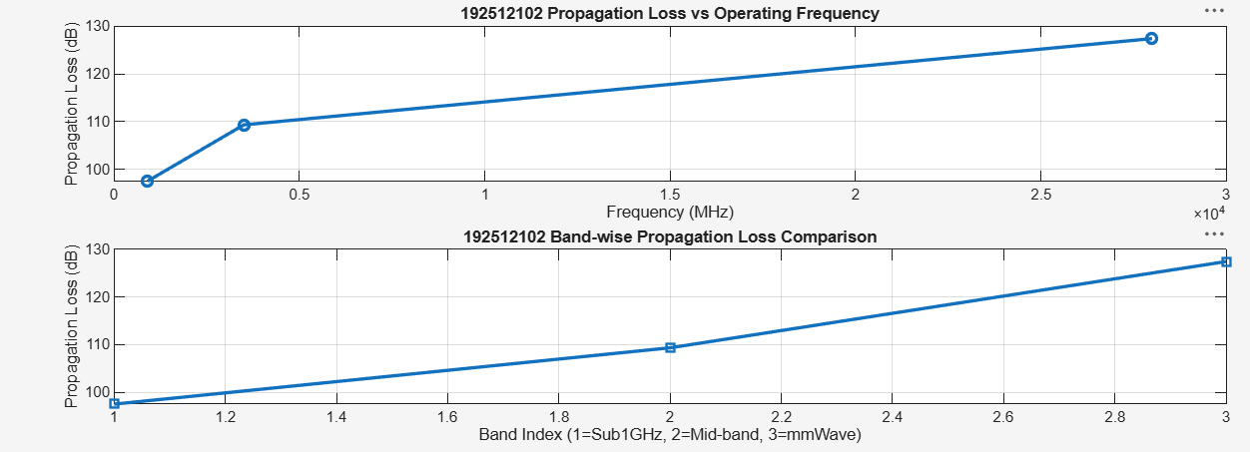
Result:
- The propagation loss was successfully computed for Sub-1 GHz, Mid-band, and mmWave frequency bands using the Free Space Path Loss (FSPL) model.
- It was observed that propagation loss increases with increase in operating frequency, with mmWave showing the highest attenuation and Sub-1 GHz showing the lowest loss.
The comparative analysis of spectrum bands clearly demonstrates that lower frequency bands are more suitable for long-range communication, while higher frequency bands require advanced techniques like beamforming for efficient performance.

